**15.Prepare tabular description of your projects’ use cases like:**

Transfer data table:

|  |  |
| --- | --- |
| USERS | VEHICLE USERS |
| EXPLANATION | User voice and led warning with sensors |
| DATA | Measure and warn distance |
| RESPONSE | User approaching any obstacle |
| COMMENTS | User must check the sensor |

**16.Draw use cases of each agents’ use cases UML diagrams of your application like:**



**USER**

**17.Draw Sequence diagrams of every action in your project like:**

LED AND VOICE WARNING

OBJECT

CAR

SYSTEM the sensor approaches the object warnings by distance

(LED and VOICE)

LEDs and sensors to park

no objects around system disabled

Easy parking of the car

**18. Draw UML classes associations of all classes like shown:**

PARKING SENSOR USING USE CASE;

 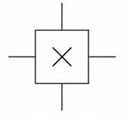

**USER PARKING SENSOR**

**19. Draw class models like shown :**

**VEHICLE**

|  |
| --- |
| **SECOND**  **LED**  **VEHICLE**  **SENSOR**  **BUZZER**  **USER** |

**20. Draw generalization hierarchy of your classes and all their details like shown:**

PARKING SENSOR

USER

ENVIRONMENTAL FACTORS

OBSTACLE

SENSOR

BUZZER

LED

DATA

LED

BUZZER

**-HUMAN**

**-** **OBSTACLE**

**-** **VEHICLE**

**-USER**

**-MEASUREMENT**

**21. Draw aggregation associations of all your classes like shown:**

USER

**LED**

**WARNING**

**VOICE WARNING**

**DISTANCE CHANGE**

**22.Draw activity model of your application like shown:**

Register

DISTANCE MEASUREMENT

START

FINISH

SAFE DISTANCE

YELLOW LED

RED LED

BUZZER WARNİNG

10 VE LESS DISTANCE

20 CM AND LESS DISTANCE

BUZZER WARNING

**23.Draw your application processes like shown:**

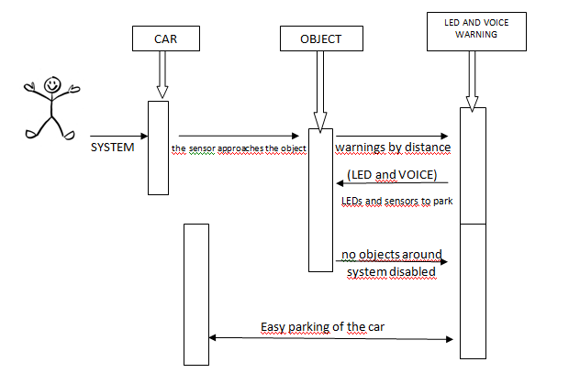

**24. Draw state diagram of your application like shown:**

MEASURING THE DISTANCE

20 CM NOT EXCEPT WARNING

THE SYSTEM WILL START

THE SYSTEM CONTINUES TO WORK..

LED AND BUZZER DOES NOT GIVE A WARNING

GIVES WARNING AT 20 CM

10<OBJECT<0

RED LED LIGHTS . GIVE A VOICE WARNING.

20< OBJECT<10

YELLOW LED LIGHTS. GIVE A VOICE WARNING.

**25.Prepare structured forms of your application’s states like shown:**

|  |  |
| --- | --- |
| **State** | **Description** |
| **Start** | Users are expected to run the system. |
| **Waiting** | The vehicle is expected to be parked. |
| **Measure** | The system is expected to make a measurement. |
| **Safe Distance** | If the vehicle is less than 20 cm from the obstacle, it will be in a safe distance condition. |
| **Exciter System** | When the system is parked, it starts to give a warning with intermittent sound under 20 cm. |
| **Danger Zone** | The vehicle is in a state that is closer than 10 cm to the object. |

|  |  |
| --- | --- |
| **Stimulus** | **Description** |
| **Start** | The user runs the tool. |
| **Waiting** | The user is expected to park the vehicle. |
| **Timer** | The sensor waits to measure the distance. |
| **Number** | The sensor determines the distance, the LCD display shows the user in cm. |
| **Sensor Open** | Under 20 cm the sensor is activated. |
| **Sensor Close** | Sensor over 20 cm is disabled. |
| **User** | The user was warned by the sensor. Led and audible warned. |

**26. Draw the software architecture of your project like shown:**

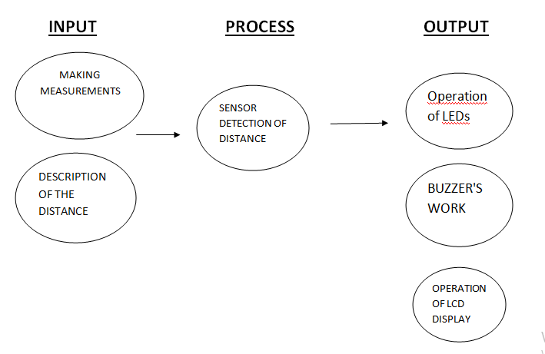

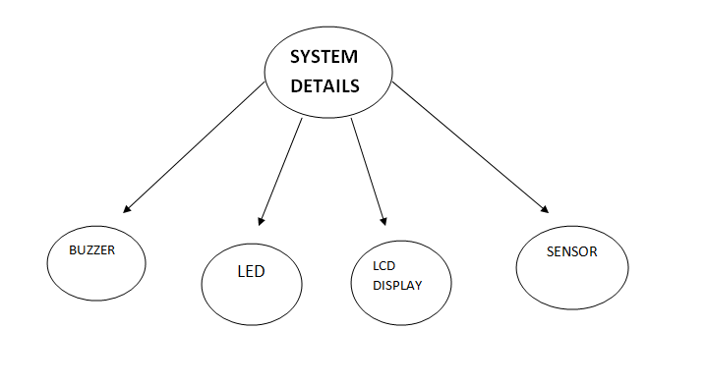

**27. Draw context diagram of your project like shown:**

KULLANICI

**1 1**

SESLİ VE LEDLİ UYARI

SENSÖR VE ENGEL

**1 1**

**1 1**

**28.Draw high level architecture of your project like shown.**

**DISTANCE IN LCD PANEL**

**LED AND VOICE WARNING**

**USER**

**ENVIRONMENTAL FACTORS**

**OBSTACLE**

**29. Draw all object classes of your project like shown:**

DISTANCE CALCULATION WARNING WITH VOICE AND LED

tone(buzzer, 1000,500);

digitalWrite(kled, HIGH);

delay(10);

digitalWrite(kled, LOW);

delay(10);

lcd.setCursor(14, 0); lcd.write((uint8_t)9);

digitalWrite(buzzer,HIGH);

delay(10);

digitalWrite(buzzer,LOW);

delay(10);

digitalWrite(kled, HIGH);

delay(10);

digitalWrite(kled, LOW);

delay(10);

digitalWrite(buzzer,HIGH);

delay(10);

digitalWrite(buzzer,LOW);

delay(10);

digitalWrite(kled, HIGH);

delay(10);

digitalWrite(kled, LOW);

delay(10);

digitalWrite(buzzer,HIGH);

delay(10);

digitalWrite(buzzer,LOW);

digitalWrite(buzzer,HIGH);

delay(10);

digitalWrite(buzzer,LOW);

delay(10);

digitalWrite(kled, HIGH);

delay(10);

void loop() {

lcd.clear();

digitalWrite(trigger, HIGH);

delay(1);

digitalWrite(trigger, LOW);

sure = pulseIn(echo, HIGH);

mesafe = (sure / 2) / 29;

lcd.clear();

lcd.setCursor(0, 0);

lcd.print("mesafe: "); lcd.print(mesafe);

if (mesafe <=10)